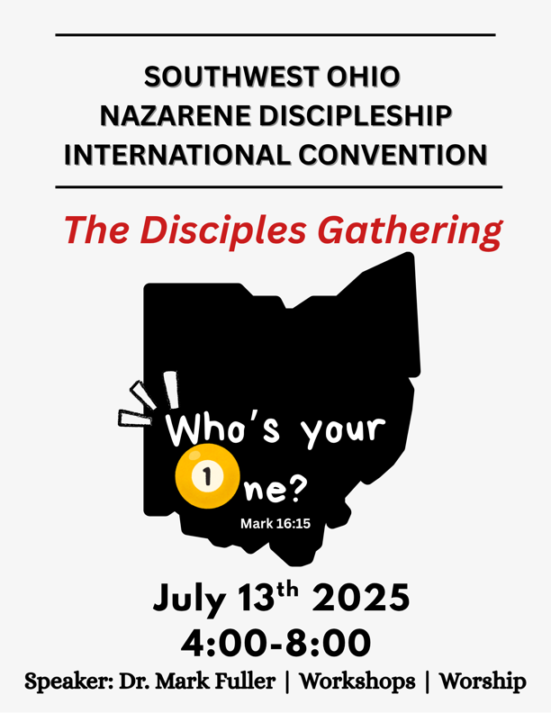

🎉 **Hey SWO Disciples—Team Nazarene!** 🎉

*NDI Convention is for Everyone in your church! Website -* [*click here*](https://editor.wix.com/html/editor/web/renderer/edit/3655bd3c-afb5-4a22-b5d5-e4b1ae25a723?metaSiteId=1a1b3b91-3844-4a70-ba14-2f75d5464b84)

We’re thrilled to invite YOU to [The Disciples Gathering](https://editor.wix.com/html/editor/web/renderer/edit/3655bd3c-afb5-4a22-b5d5-e4b1ae25a723?metaSiteId=1a1b3b91-3844-4a70-ba14-2f75d5464b84), our SWO NDI Convention happening during District Assembly!

📍 **Where:** Springdale  
📅 **When:** **Sunday, July 13th at 4:00-8:00 PM**

This isn’t just another meeting—it’s a movement. Whether you’re a long-time disciple or just beginning the journey, this event is **for you**.

**Bring all your disciples!-- pastors, small groups leaders, Sunday School teachers, disciple-makers or anyone who wants to be!**

**Register- email** [**kalynv73@gmail.com**](mailto:kalynv73@gmail.com)

💬 **What’s happening?**  
Get ready for an inspiring time of growth, connection, and encouragement as we gather together ***to strengthen our disciple-making mission***!

✨ **Keynote Speaker:** Dr. Mark Fuller will kick things off with a powerful plenary session

🛠️ **Interactive Workshops:** Choose from 2 engaging workshop sessions designed to equip and energize your ministry in fresh, practical ways.

Info about all 5 workshops—[Click here!](https://editor.wix.com/html/editor/web/renderer/edit/3655bd3c-afb5-4a22-b5d5-e4b1ae25a723?metaSiteId=1a1b3b91-3844-4a70-ba14-2f75d5464b84)

Come ready to be refreshed, challenged, and united in the mission. Let’s gather as disciples—and leave as disciple-makers.

🙌 We can’t wait to see you there!

On the Journey with you,

Pastor Kalyn Vogelmann & The NDI Team!

See workshop information below!

**SWO *The Disciples Gathering WORKSHOPS***

* ***The Pastor as Disciple-maker*** |**Dr. Mark Fuller**

In this workshop we will address the leadership keys to developing a culture of disciple-making at every level of ministry in the church.

* *​​* ***Alpha In the Local Church |* Pastor Dale Benson**

***Alpha USA (click here to learn more about Alpha)*** Discover how Jesus transforms lives in the local church. In this workshop we will talk about what you need to get Alpha started in your local church and hear real transformation stories about the ways God is using Alpha to help others know God and love God.

* ​***Insatiable Curiosity - A Compelling Approach in a Skeptical World.—***

***"Good newsing”* | Dr. Jeff Stark**

​In an increasingly suspicious and skeptical age, trust is the currency of intentional friendship. Throughout this workshop, we will examine the necessary characteristics to forge connections with those disconnected from the hope of Jesus, preserve their dignity, attend to their doubts, and provide a "good newsing" compelling witness.*: Coming Soon*

* **Engaging Kids with the Gospel: Creative Ways to Disciple Children and Families | Pastor Emily Skillen (Grubs)|**

In Matthew 19:14, Jesus said, “Let the children come to me. Don’t stop them! For the Kingdom of Heaven belongs to those who are like these children.” Isn’t it amazing to think that people of all ages - including children - are invited to be a part of God’s Kingdom? No one is left out! In this workshop, we’ll discover creative ways to share the gospel with children and how to partner with parents to help them disciple their children at home.

* **Building a Strong Biblical Worldview Into the Next Generation | Tim Throckmort**

The most prevalent question I’ve heard in the last eight years listening to church members in America has been, “what can I do?” This session begins by taking a real-time look at the current landscape of worldview in the family and culture with the latest research from George Barna and the Center for Biblical Worldview at the Family Research Council. We will then observe ministry trends that emerge as Christians grasp the need and to respond with Biblical solutions.***​​***

USE THIS FOR YOUR Local church email or social media invitations.

🚨 **Calling all SWO Disciples – Team Nazarene!** 🚨

Don’t miss **The Disciples Gathering**  
📍 Springdale | 📅 Sunday, July 13 @ 4PM

Join us for an inspiring plenary with **Dr. Mark Fuller**, plus 2 powerful workshops to fuel your disciple-making mission!

💥 Grow. Connect. Be equipped.  
🙌 This is for ALL disciples—**yes, YOU!**

Let’s gather together and go deeper in the mission. See you there!